SRM UNIVERSITY-AP
Department of Computer Science and Engineering
CSE 101 – Fundamentals of Computing and C Programming
30-DAY C PROGRAMMING CHALLENGE – CHALLENGE 01
CHALLENGE DETAILS

Student Name | ABINAV S | Registration No. | AP26110090139
Challenge No. | 01 | Date | 21-09-2026 TO 23-09-2026
1. PROBLEM STATEMENT

A student has marks for five subjects. Write a C program to read the marks of all five subjects and calculate the total marks, average marks, and percentage. Display all three results clearly.
2. OBJECTIVE

To practice variables, data types, input/output statements, arithmetic operators, and basic expression evaluation in C.
3. ALGORITHM
2. Read the marks of five subjects.
3. Calculate the total marks.
4. Calculate the average marks.
5. Calculate the percentage.
6. Display the total, average, and percentage.
7. Stop.
1. Start
2. put Int M1,M2,M3,M4,M5
3. Put Float TOTAL,AVERAGE,PERCENTAGE
4.Read M1,M2,M3,M4,M5._______________________
5.TOTAL = M1+M2+M3+M4+M5. ________________________________________________
6.AVERAGE MARKS = (M1+M2+M3+M4+M5)/5. ________________________________________________
7.PERCENTAGE = (TOTAL/500) X 100________________________________________________
8.print the TOTAL,AVERAGE,PERCENTAGE
9.STOP.________________________________________________
4. C PROGRAM
Program :
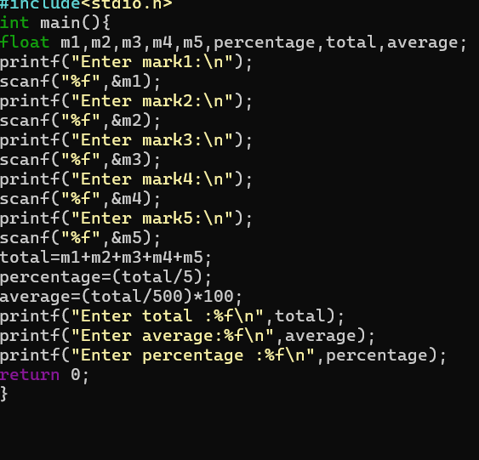

5 TEST CASES & RESULTS

Test Case | Input | Expected Output | Actual Output | Status
TC01 | 80, 75, 90, 85, 70 | Total = 400; Average = 80; Percentage = 80% | Enter total :400.000000  Enter average:80.000000  Enter percentage :80.000000 | Output verified
TC02 | 65, 72, 68, 75, 80 | Total = 360; Average = 72; Percentage = 72% | Enter total :360.000000  Enter average:72.000000  Enter percentage :72.000000 | Output verified
TC03 | 95, 88, 92, 90, 85 | Total = 450; Average = 90; Percentage = 90% | Enter total :450.000000  Enter average:90.000000  Enter percentage :90.000000 | Output verified

Faculty Coordinator: Dr. Yasir Afaq
SRM UNIVERSITY-AP
Department of Computer Science and Engineering
CSE 101 – Fundamentals of Computing and C Programming
30-DAY C PROGRAMMING CHALLENGE
SUBMISSION FORMAT

Submission Format – Challenge 01
STUDENT & CHALLENGE DETAILS

Student Name | ABINAV S | Registration No. | AP26110090139
Challenge No. | 01 | Date | 21-09-2026 TO 23-09-2026
REQUIRED SUBMISSIONS

No. | Submission Requirement | Link / Submission
1 | GitHub Repository / Challenge Folder
2 | LinkedIn Post Link
3 | 60-Second Explanation Video Link
GITHUB REQUIREMENTS

• Upload the C source code.
• Include the algorithm / README.
• Include relevant test results or output evidence.
• Maintain all challenges in one GitHub repository.
60-SECOND VIDEO

Maximum duration: 60 seconds
Include: Problem → Approach → C Concept Used → Result
EVALUATION – 10 MARKS

Evaluation Component | Marks
Algorithm | 2
C Program & Execution | 3
Test Cases & Results | 3
GitHub & LinkedIn Submission | 2
TOTAL | 10

Student Signature
Abinav

Faculty Coordinator: Dr. Yasir Afaq

